**Seniors Managing Diabetes**

**Phase 3**

Group 10:

Jeremy Johnston <jeremy.johnston@mail.utoronto.ca>

Jhony Campanha <j.campanha@mail.utoronto.ca>

Joseph Lee <josephl@live.ca>

Eric Siu <eric.xue@mail.utoronto.ca>

Marc de Niverville <marc.deniverville@mail.utoronto.ca>

**User Research Results**

**Summary:**

The research that was conducted individually in our group was mainly focused on seniors with diabetes, and their interaction with technology. Through this research, we were able to find a few similarities among the seniors that suffer from this condition. For example, many of the seniors did not find it hard to manage their condition. Although they did not have trouble managing it, it took them years to get accustomed to their schedule and remembering every procedure. For those that were cared for by medical professionals, they were guided in a professional manner and were able to adapt to the condition faster than some of the other seniors who did not receive this professional attention. Not only were they able to get familiar with their condition, but those who had visited a medical professional often also had more modern technology and received instruction in how to use them. Moreover, many of the seniors also found that technology itself is not useless, but rather the application interface may not be suitable. They believed that the technology was the right way to go but the applications designed for it were poorly made. This includes the fonts, pictures, size of texts, and visual issues. Lastly, it was found that some of the seniors did not approach the technology because they were unsure of how efficient and how accurate it is. They would have no problem in learning it, but sometimes the technology is complicated and no one is there to help them, so they would rather stick with old technology.

**User needs list:**

Upon first being diagnosed with diabetes, one needs to take precautions with treating it.  
Newcomers to diabetes should do the following:

* Stabilize their condition
* Know the repercussions of not treating it properly
* Learn how to manage it
* Learn the devices to keep track of information
* Learn what to do with that information
* Learn about how to go through a normal day and deal with the condition

For someone who is a regular or is already diagnosed:

* Create good habits in their life
* Check their vitals and conditions regularly
* Check blood glucose levels
* Regular check-ups from a medical professional to know of their condition

Some of the applications or technologies that diabetics can use are:

* Applications that monitor blood sugar levels
* Applications with reminders of exact time of medications
* Applications that can recommend food
* Applications that automatically log the food eaten

**Stakeholders’ descriptions:**

There are many people affected in our system when we are gathering information on diabetics, as well as people being affected by people who have diabetes.

**Seniors with diabetes**: The targeted user, they are in need of some useful application to help in the diabetes self-management.

**Family**: if meals are shared with family, then their support is required to maintain a fat- and carbohydrate-controlled diet. If the spouse does the shopping and cooking, then they play a key role in implementing the diet plan. Tech support for computing devices may also come from family members.

**Researchers:** they take an important role in finding out what can make the subjects lives easier. They try to look for data that will make the technology more appealing to seniors.

**Friend:** they were reported to offer tech support for computing devices. They were also relied on for understanding when their diet choices might conflict.

**Health care providers (doctors, nurses, pharmacists, nutritionists)**: key in providing ongoing services for monitoring long-term blood-glucose levels and creating the daily regimen of diet, exercise, and insulin booster dose.

The **manufacturers** of contemporary blood-glucose monitors have enabled direct, reliable, and affordable monitoring of blood-glucose levels. This tool gives users the feedback that they need to check their state as often as they require to effectively manage the three factors influencing equilibrium.

**Primary Personas:**

• Betsy is a Caucasian 64 year old who has been diagnosed with diabetes since the age of 12. She lives in Toronto and has a job as a receptionist in a law firm. She lives alone in an apartment but has a busy lifestyle. She has had plenty of time to learn how to deal with her diabetes and has got it down pat. However, old age and her busy lifestyle is start to best her. Recently, she sometimes forgets to record her blood sugar level and taking her insulin. Betsy likes to exercise but has recently neglected it due to her work and age. Betsy decides she needs some help as time is getting the best of her. Since she lives alone she needs something she can do by herself. Betsy tries some of the health apps that are out there with her phone but none of them seem to help. She feels like they are too hard to navigate and do too many unneeded things. Betsy needs something that not only tracks her eating habits, but can track her blood sugar level, remind her to take insulin, and incentivise her to exercise. “I want something that does what I need and does not have the needless clutter of extra things”.

• Recently retired, Jill has recently been diagnosed with type 2 diabetes. She is quite concerned. Her web surfing has revealed all sorts of horror stories about diabetes gone wrong. The doctor has told her that she needs to make many lifestyles changes, but they are much more easily said than done. Jill wants to quickly get her situation under control. She would like life to go on as normally as possible, and to continue to enjoy the things that really matter to her. Jill does not regularly exercise, and while she is somewhat aware of the diet choices she should be making, she has rarely attempted to maintain a strict discipline over what she eats. Jill has sufficient comfort with and knowledge of computers to use email and browse the web, but this is the full extent of her interest in learning about computers. She relies on family, friends, or the local Geek Squad to resolve technical issues.

• Sally is an 87 years old and use to work for an accounting firm that has a lot of influence in the business world, which brings a lot of stress into her life. She has worked in the job for 30 years and knows it well, practically inside out. Many of the younger accountants use to ask her for advice due to her professionalism in the career. Despite being very good at her job, she has a condition which limited her working capabilities. She suffers from type 2 diabetes and has to constantly monitor her condition or else she cannot perform well. Because she had to monitor it a lot, she had to take the technology what was available in the 80’s to help her, however now that there is not as much stress in her life, she hasn’t bothered to learn the new available devices.

Lately she has been feeling down as her family is moving away from her hometown which leaves her alone in the city. This leads her to taking care of herself and monitoring her condition without the aid of anyone else. She notices that the technology she is using has been malfunctioning lately and cannot get the parts to replace it as they have been discontinued.

She has used many instruments to look at her condition but over time she eventually stopped caring as less stress has been put upon her. However with the increasing number of times of her equipment being malfunctioned, she turns to newer technology but cannot comprehend how to use it or how affective it will be. She wonders how she will get use to the newer technology without being a burden to her family and make it easier for her to live by herself whilst monitor it all.

**Scenarios:**

• Jung-Ja is an old retiree who lives on the outskirts of town alone. She use to have family members living with her to remind her about her diabetes condition, but as of late they have all moved to the urban part of town. Not being use to this, she forgets one day to measure her blood glucose levels with her CGM and forgets to inject insulin into herself through an insulin pump. While her daily exercise routine, she realizes she is more tired than usual and has a blurry vision, but she could not remember why because nothing or no one reminded her to monitor her condition.

• Betsy is a diabetic and works as a receptionist at a law firm. Her doctor gave her a booklet in order to keep track of the food she eats and her blood sugar level. One day while at work she realises she forgot the booklet from her doctor. She becomes stressed as she needs it in order to figure out what to eat

•Jill is feeling a little groggy this morning. This may be due to the poor sleep she had last night or that she hasn’t had breakfast yet and her blood sugar is low.  
She has lots of plans for the day: a lunch date with friends, and then a walk through the botanical gardens with them.

•Jill is at lunch with her friends and they are discussing what on the menu is most appealing, and the wisest choices for their weight-reducing diets. Looking ahead to the afternoon, Jill knows that should eat healthily but also adequately in order to last through the 1-2 hour walk that is planned for the afternoon. She knows that her diet must different from her friends’, but how?

**Design Requirements:**

The problem that we are addressing is how elders with diabetes manage their health. With old age comes memory loss and the possibility of living on your own. Thus our job is to help elders keep track of what matters when it comes to managing their health. This means that monitoring blood sugar, getting exercise, reminders for insulin intake and dietary choices are our top priorities.

**Design Principles:**

Simple - Our audience needs to be able to use the app without help and thus it should be very intuitive.

Streamlined - There will not be clutter or an overuse of visual elements and features. Our users will be using our app for a specific purpose and we do not need to overwhelm them with options they will never use.

Intelligent – Exercise and dietary advice needs to good advice. Also need to not annoy the users with the reminders.

**User Needs:**

* Blood sugar tracking and insulin reminders
* Exercise advice and exercise logs
* Dietary advice and logs.
* Expert advice to adjust the regimen when required

**Environmental Requirements:**

Our app is meant for personal use and can be used in any environment. Logs will be updated after an exercise session or after eating.

**Functional Requirements:**

Our app will need to be able to keep track one month of information such as blood sugar level, exercise logs, and food logs. It will also need to be able to set reminders for when to eat, take insulin or exercise. The logs should be able to be viewed and be kept track of for up to a year. The reminders should be set by the user and automatically by the system. The reminders can be set to any time for daily, weekly, or monthly intervals.

**Technical Requirements:**

Our app needs to be able to work on a device that is portable and lightweight in which users can keep the device on them at all times. The device should also be able to emit noise and vibrate in order to notify the user of the reminders. We will also need enough memory to keep logs of exercise, food, and blood pressure.

**Usability Requirements:**

Our app should be incredibly easy to learn and use as our user group needs to be able to use it without help. Any errors should not affect the logs that have been recorded or the reminders that have been set as they are the most important.

* **Short-Form Creative Brief**
* **Project Objective:**
  + Our project will help people in their ultimate goal of extending their lives and improving their quality of life, by helping them to maintain the equilibrium of diet, exercise, and insulin boost.
* **Key Personas:**
  + Jill. Recently retired, she has been newly diagnosed with type II diabetes, and must establish an effective daily regimen. She is not confident about learning new computer technologies, and is feeling overwhelmed.
  + Betsy has been coping with diabetes since the age of 12. Recently, she has been forgetting to record her blood sugar level and take her insulin. Betsy used to like exercise but has been neglecting it. Betsy has decided that she needs some help.  
    “I want something that does what I need and does not have the needless clutter of extra things”.
* **Key Scenarios:**
  + Jill is feeling a little groggy this morning. This may be due to the poor sleep she had last night or that she hasn’t had breakfast yet and her blood sugar is low.  
    She has lots of plans for the day: a lunch date with friends, and then a walk through the botanical gardens with them.  
    Jill has just read her blood glucose, but can’t figure out what she should eat to perk up and be ready for the day’s activities.
  + Jill is at lunch with her friends and they are discussing what on the menu is most appealing, and the wisest choices for their weight-reducing diets. Looking ahead to the afternoon, Jill knows that should eat healthily but also adequately in order to last through the 1-2 hour walk that is planned for the afternoon. She knows that her diet must different from her friends’, but how?
* **Key Principles, our system:**
  + is not reliant on user’s technical aptitude
  + anticipates the user’s needs for information and suggests the decisions that should be made
  + at any time, only presents the critical information required at that time
  + is robust: no system error will prevent it from performing its critical functions
  + is unobtrusive unless action is required

# Experience Map

In this section, the experience map for the problem is shown. This map shows the whole experience of someone with diabetes, since before the diagnosis, and passing through his/her whole experience with diabetes. This map was created based on interviews, questionnaires and observations made with seniors with diabetes. The experience map showed below has five different sections: *Entice, Enter, Engage, Exit, Extend.* Each of these sections has some attributes related to the section.

# Entice

In this section is found the causes that bring seniors to diabetes. These are what called their attention and the main causes for their problem.

## Sugar Desire



Image 1: [consciouscooking.com](http://consciouscooking.com) Image 2: [images6.fanpop.com](http://images6.fanpop.com)

Usually, before being diagnosed with diabetes, the senior was used to have a non-healthy diet. The desire for sugar is one of the major causes for the diabetes.

## Failing the promise of returning to a health lifestyle



Image 3: img2.timeinc.net

The seniors usually made health resolutions before being diagnosed, but they have never been able to fulfill them.

# Enter

In this section is found the beginning of their lives within diabetes.

## Diagnosishemochromatosis-diagnosis.jpg

Image 4: hemochromatosisdna.com

The diagnosis is the entrance mark for their lives with diabetes. After being diagnosed, a lot of changes in their lifestyle occurs.

## Habit changes

## Changing.jpg

Image 5: lifestyleupdated.com

A big amount of changes occurs in the daily life after being diagnosed with diabetes. Since diet changes until the need of exercise, any change is made in order to get better life conditions.

## Training

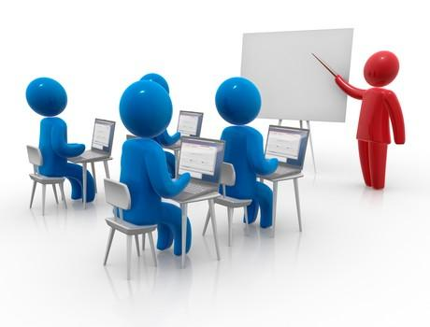

Image 6: [designvisionaries.com](http://designvisionaries.com)

Due to big amount of habit changes, people diagnosed with diabetes need trainment to correctly use the monitors, or to correctly follow a good lifestyle. Sometimes this trainment step do not occur, with can cause trouble for the patient.

# Engage

In this section is found what occurs during their lives within diabetes.

## Symptoms

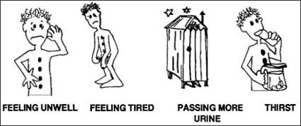

Image 7:wikieducator.org

During their whole live with diabetes, usually they will suffer some symptoms and need to take the exactly medicine to deal with that.

## Doctor visits



Image 8: tricare4u.com

Frequently, the person managing his/her diabetes will need to learn to self-manage. However, the presence of a doctor is not avoided. Usually, consults with doctors will occur to make sure that everything is being done right.

## Good lifestyle



Image 9: med-health.net

Keeping a good lifestyle will be always necessary to avoid trouble for a diabetic. A good lifestyle can decrease the number and the frequency of the symptoms.

## Using monitors

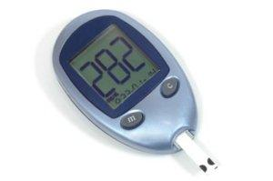

Image 10: raw-food-health.net

Usually, the person managing his/her diabetes will need to use some monitors to guide him/her in the management. These devices are essential for their lives because of the importance in knowing the real glucose levels.

# Exit

In this section is found the experience of exiting the self diabetes management life.

## Abandonment of devices

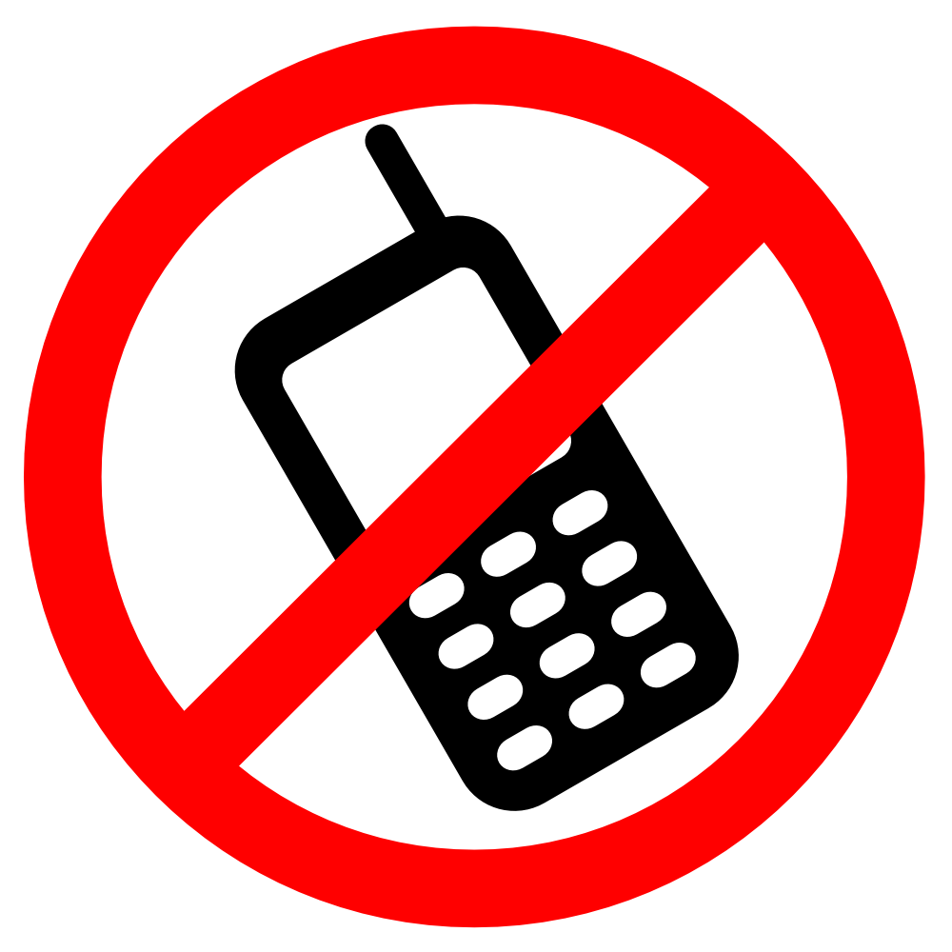

Image 11: images.onlinelabels.com

Diabetes is a problem for the whole life. Because of that, when one device becomes unnecessary, it is considered more freedom for the patient, which is an exit proccess of the diabetes.

# Extend

In this section is found anything that can help the patient after the exit step. Anything that can keep the safeness of his/her health condition.

## Doctor’s accompaniment

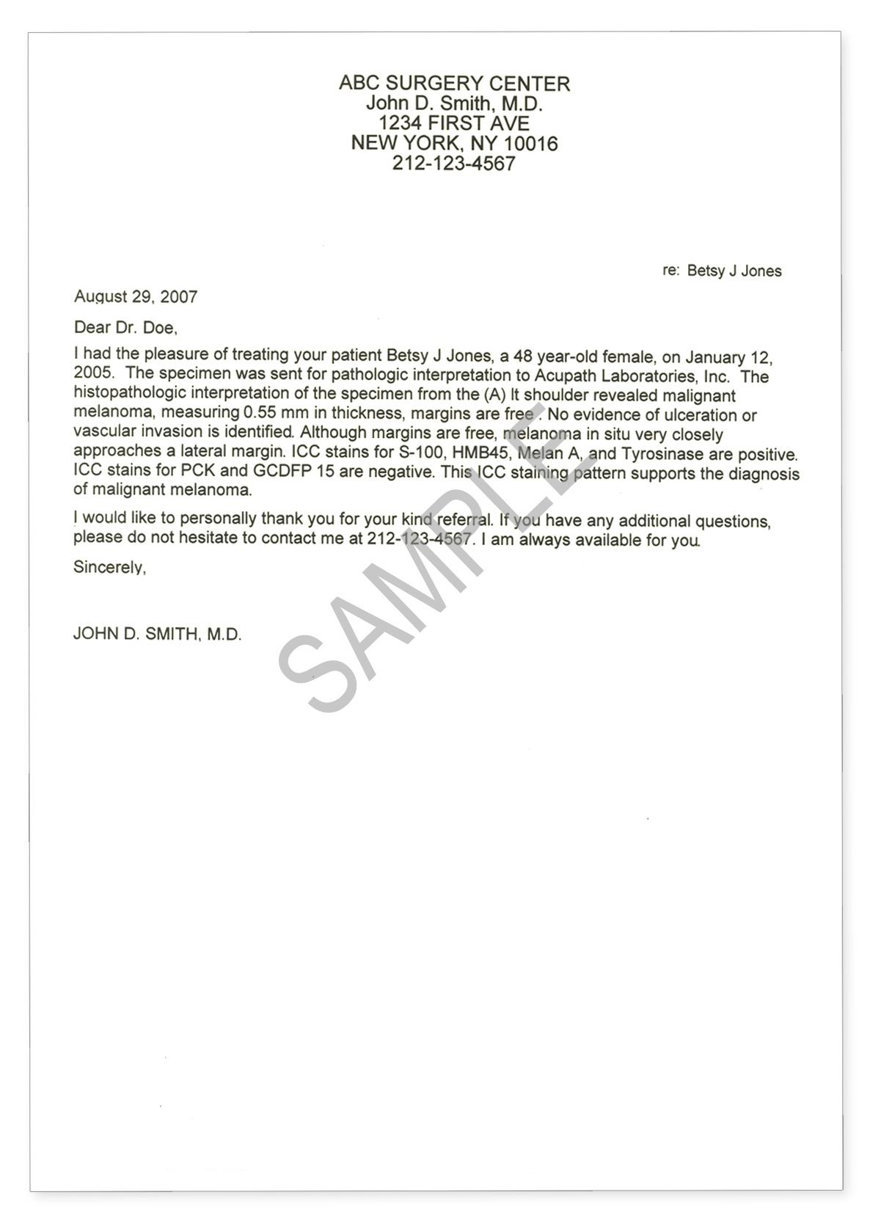

Image 12: acupath.com

The doctors will still maintain contact with their patient to make sure that they are having a health life without any trouble.

## Feeling better due to their success



Image 13: quickanddirtytips.com

Having success in their diabetes self management makes them emotionally better, which is good for their health as well.

# Conclusion

This experience map showed the whole experience of a patient suffering from diabetes. By using this map, we can understand the steps with issues and try to give a solution to them.